

Q-Learning Management System
User manual

How to record attendance in a training session
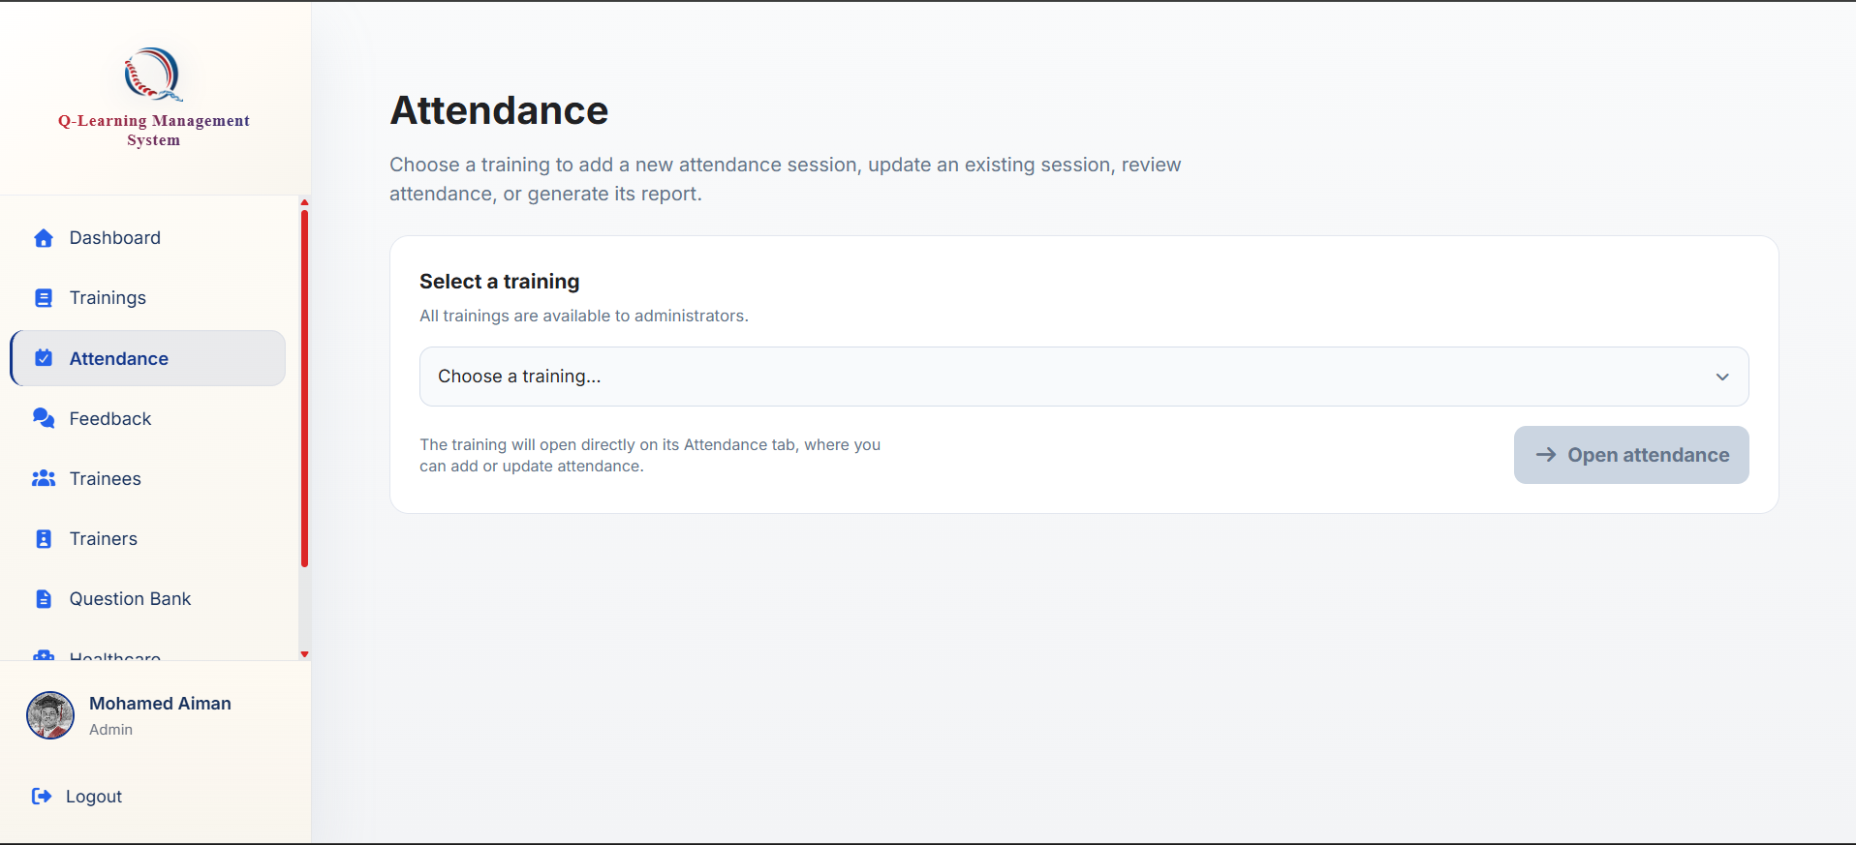

Go to the attendance tab



Choose your training over here

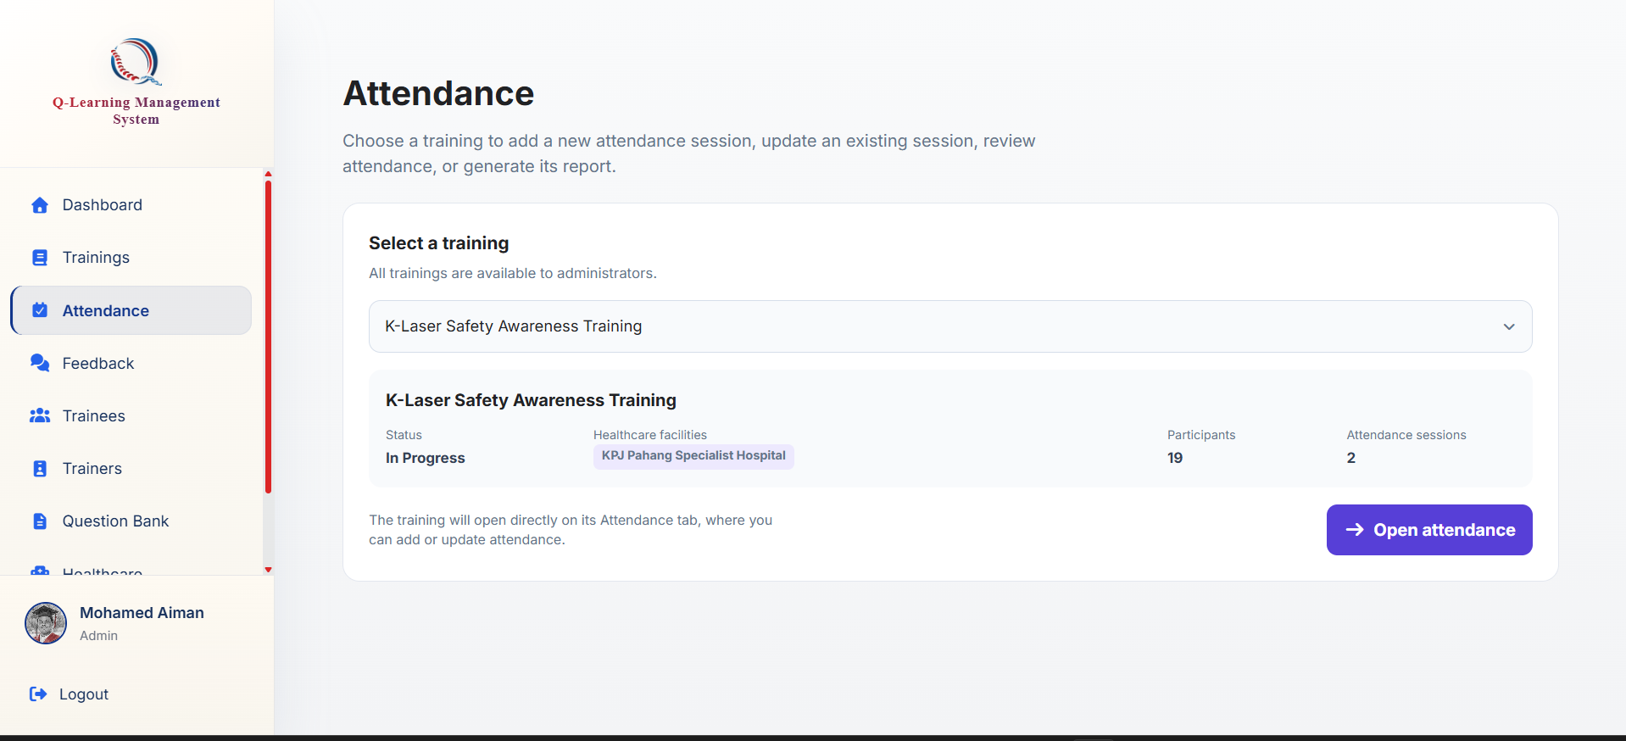
Click on this button to go create an attendance record

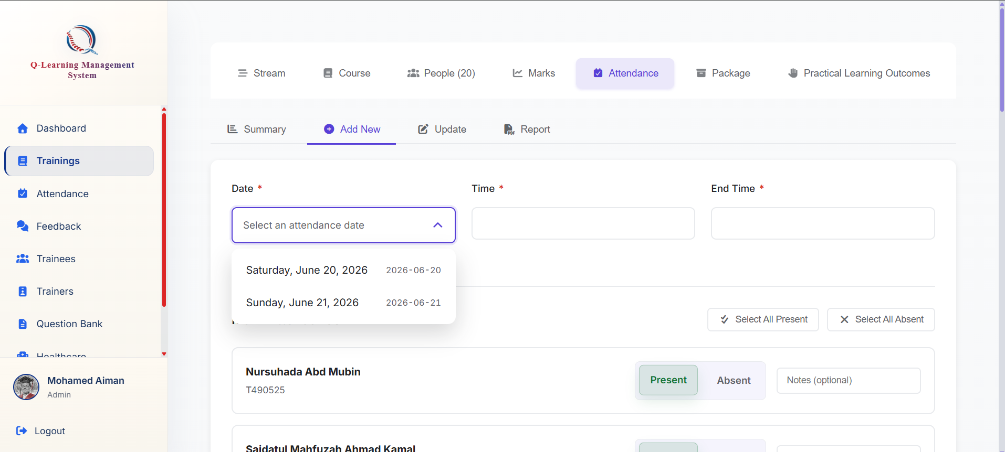
Just fill in the date and time, as well as the end time for the attendance, followed by ticking the attendance down here

